Editorial Brief Doc
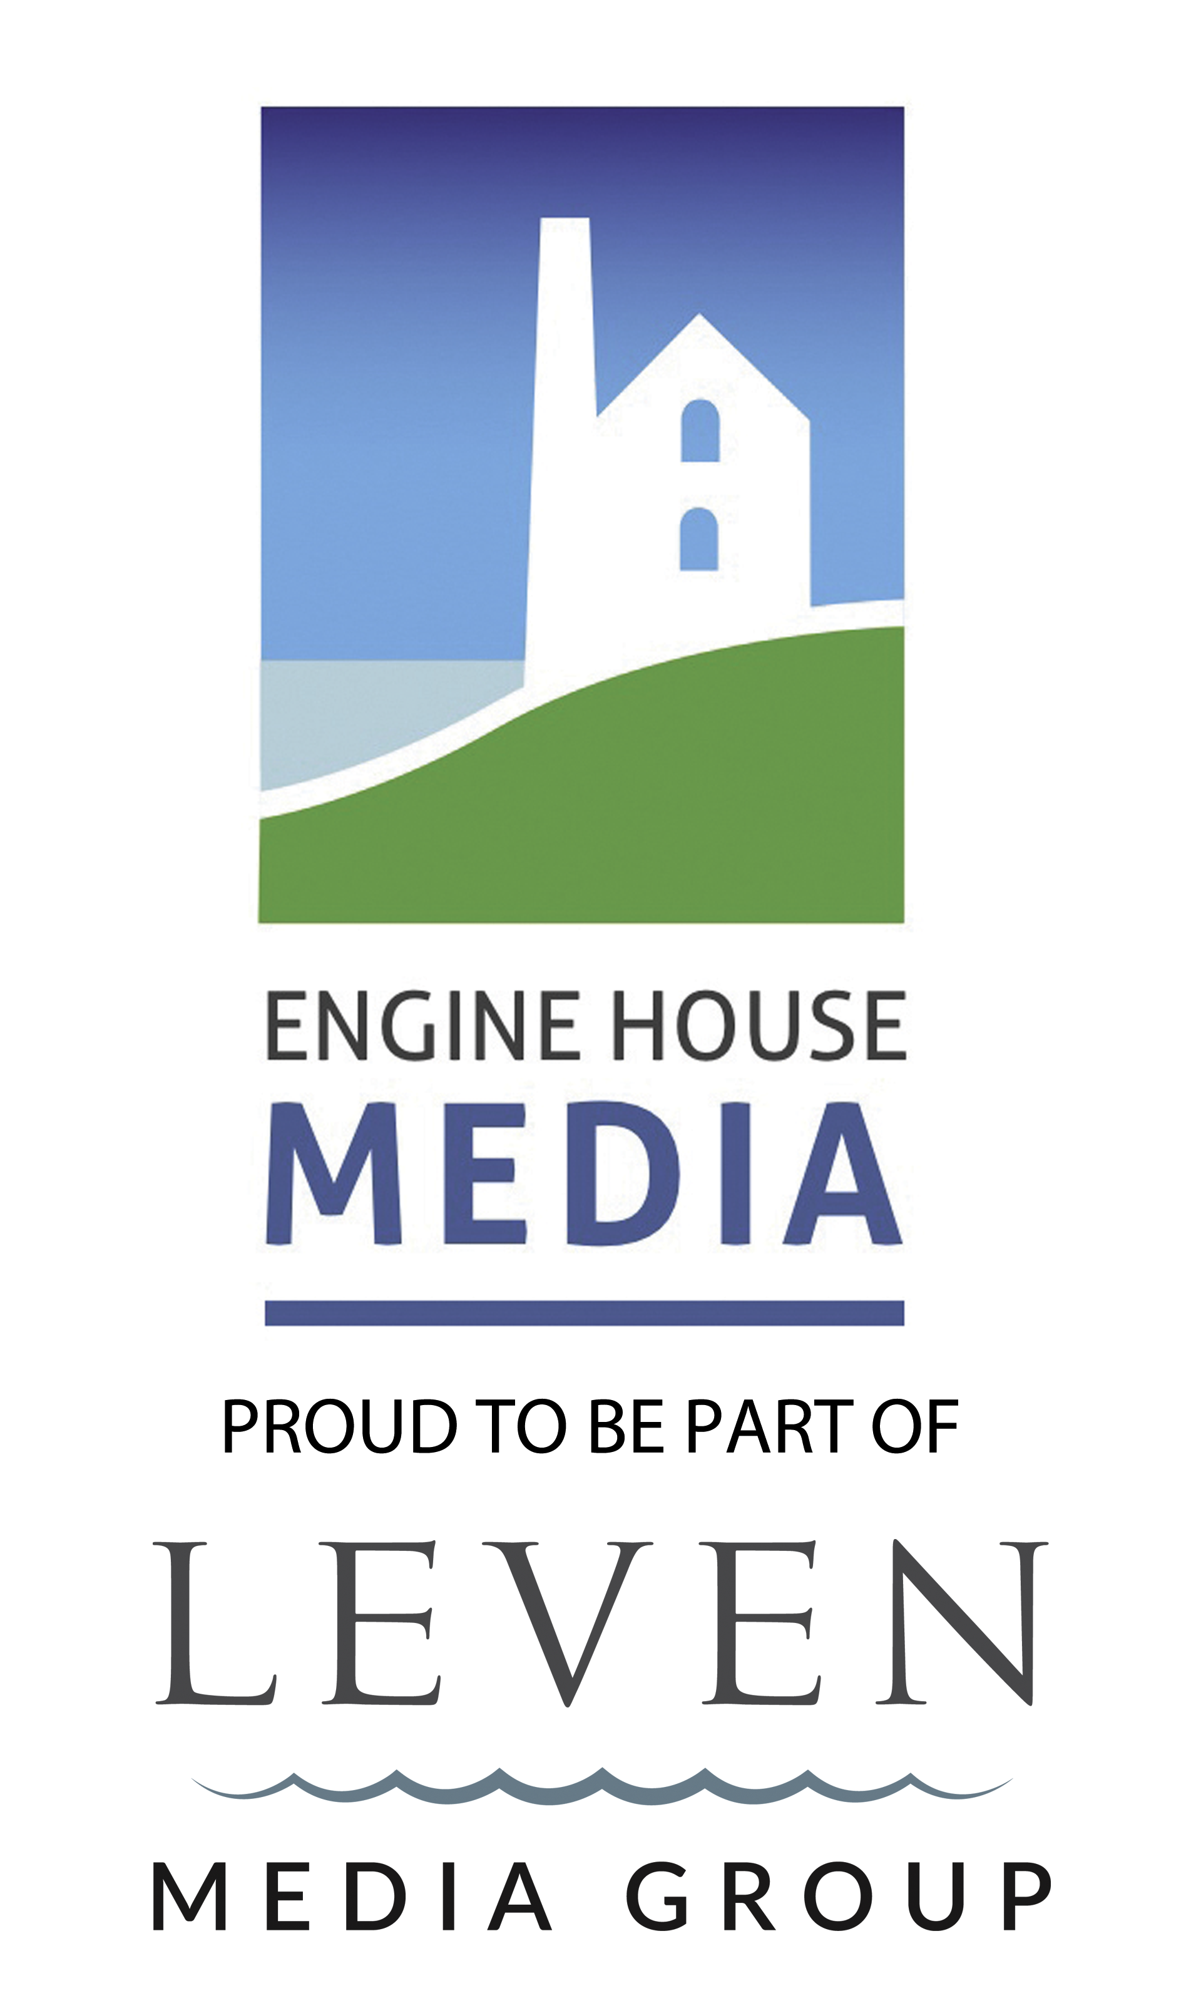
Please return this file to us along with your imagery so we can get started with creating your content in print, online and digital.

Double Page Editorial
Full Page Editorial
Got to Experience
Cottage Feature
News Feature (single)
• 700 words
• Contact details
• 5-7 high-res images
• 50-100 words + Contact details
• 1 WOW image (needs to be very large and landscape) + 3 smaller inset pictures
• 200 words + cottage name
• Web address & Phone
• 3-5 high-res images
• 120 words
• Web address & Phone
• 1 high-res image

• 300 words
• Contact details
• 5-7 high-res images

Need a hand with your content?

Step 2: Write a short paragraph about you and your company, or supply a link to your ‘About Us’ page:

Type in here.

Step 1 – Tell us which services/products/news you would like to promote in this issue:
- Point 1
- Point 2
- Point 3
- Point 4
- Point 5

Step 3 – Perhaps you have some interesting content online? If so, pop the links in here (please don’t include your ‘About Us’ page; see Step 2):

Paste in here.

If you’re unsure what to write about, give us a call on 01326 574 842 and ask to speak to a member of the editorial team.

Please bear in mind that editorials do not carry a company logo

